Anton T. Pedres

BUILT DIFFERENT. WIRED STRONG, BUILDING A PERSONAL PRIVATE LEGENCY
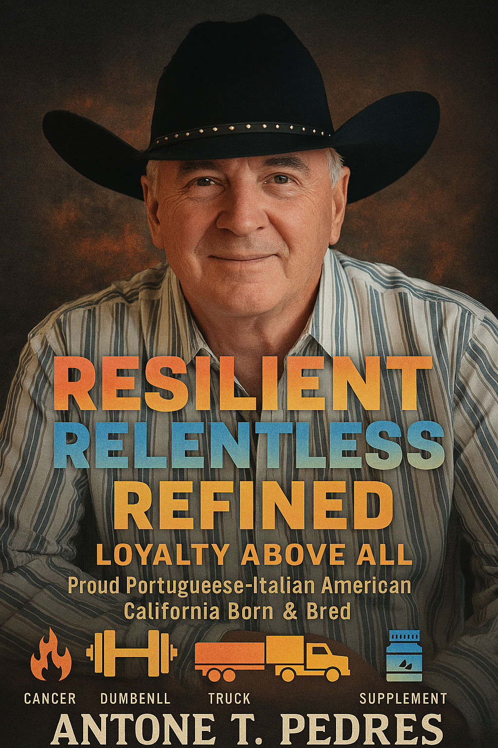
💥 RESILIENT. RELENTLESS . DISCIPLINED . SELF-MOTIVATED. MANNERED . and FAIR.
AGE: 73 years …. Height 5’ 7” …. Weight 190 lbs.
Health: Excellent: Physical Condition Toned and active build
Interests: Cooking, Driving, Physical Conditioning, Good simple food.
STATUS: Retired Veteran | Creator | Professional Driver / Driver Safety Trainer
Health Strategist | Nutrition Advisor | Supplement Stacker
LOCATION: Everywhere, purpose moves me, Rolling Along the California
Highways, in the great outdoors or the coastlines it’s all good.
ROOTS: Country-raised with pride, respect, manners and a cowboy love for
Life, a proud Portuguese Italian American — California Born & Bred

Anton runs with the fire and determination of a man half his age, with the wisdom of one who’s lived a dozen lives. A decorated veteran of multiple U.S. public service backgrounds and disciplines that he has served. He has transformed his mission into a personal code: Stay frosty, Stay strong. Be alert. Leave behind something that matters, Loyalty Is Essential, Be humble and kind — but always carry a big FREAKIN’ stick.

CORE ROLES
• Health & Supplement Strategist / Professional Driver & Safety Trainer / Nutrition Advisor & Supplement Stacker / Lifestyle Creator for Resilient Living / Senior Diet Architect
Cancer survivor. Dedicated Gym regular. Accomplished Sou Chef, Tactical thinker and around good fellow, Anton does not follow trends — instead, he builds tools that work. From high-mileage California hauls to high-performance supplement stacks and driver fuel blends, for alertness and stamina, he moves with precision, purpose, and personal conviction. Evaluated by fire. Refined through decades of performance. Anton leads with grit, not glory. Titles do not matter — results do, and the mission must always be completed? Still running. Still strong. Still building — with righteousness and bold conviction, while always being true to one’s own self.
GUIDING VALUES
- No fluff. No shortcuts. No excuses.
- Loyalty, dedication, fact, and discipline.
- No one stands alone — and no one is ever left behind.
- If it is real and built to last — he is in. If not — he is out
- If You Have Loyalty, Everything Else Follows, Then All Falls into Place

SOCIAL BIO | SHORT FORM
Anton T. Pedres
73 | California Born | Resilient Driver | Cancer Survivor | Veteran of Service
Gym-Built | Nutritional, Supplement & Senior Diet Mentor
Proud Portuguese-Italian American
Believer in Loyalty Above All — If You Have Loyalty, Everything Else Falls in Line.
Country Raised. Cowboy Mindset. Cowboy Manners. Always Visible to the Present.

